Machine Learning and Explainable AI for Residential Property Valuation in Dubai

Abstract
Accurate property valuation is a cornerstone of a healthy real estate market, crucial for investors, developers, and policymakers. In highly dynamic and globally integrated markets like Dubai—characterized by rapid development, luxury segments, and significant foreign investment—traditional linear valuation methods often fall short. These conventional hedonic models struggle to capture the complex, non-linear relationships and hidden variable dependencies inherent in modern housing markets.
This research develops an advanced, data-driven framework for predicting residential property prices in Dubai using supervised machine learning. Utilizing official transaction data from the Dubai Land Department (DLD), the study evaluates the performance of multiple algorithms: Linear Regression, Decision Trees, Random Forests, and Extreme Gradient Boosting (XGBoost). To overcome the "black-box" limitation often associated with complex predictive models, the study integrates Explainable Artificial Intelligence (XAI) via Shapley Additive Explanations (SHAP).
The empirical analysis demonstrates that ensemble learning models significantly outperform traditional linear regression. Following rigorous feature engineering—including geospatial target encoding and logarithmic transformations—the Random Forest model emerged as the champion, explaining over 81% of the market variance and achieving a Mean Absolute Error of 360,266 AED. The SHAP analysis provides transparent, quantitative insights into feature influence, confirming property size (procedure_area) and localized geographic mean pricing as the dominant valuation determinants. The project culminates in the deployment of an interactive Streamlit web application, bridging the gap between theoretical predictive analytics and practical real estate decision-making.

Chapter 1: Introduction

Background and Motivation
The real estate sector is a vital engine of economic growth, particularly in rapidly urbanizing regions. In Dubai, the property market is not merely a domestic asset class but a globally significant investment hub. Characterized by high transaction volumes, a focus on luxury developments, and a large expatriate population, the market is both highly dynamic and inherently complex. For stakeholders ranging from individual homebuyers to large-scale developers and financial institutions, the accurate appraisal of residential property value is essential for risk mitigation and strategic planning.
Historically, property valuation has relied heavily on the hedonic pricing theory, which posits that a property's total value is the sum of the implicit values of its individual structural and geographic components. In practice, this has involved using multiple linear regression to estimate the implicit marginal price of specific features—such as the number of bedrooms, square footage, and proximity to the city center.
While traditional multiple linear regression models offer a strong theoretical foundation and ease of interpretation, they are severely constrained by the assumption of linear relationships between variables. In reality, the Dubai market exhibits significant non-linearities; the value added by a specific amenity or a highly sought-after location may scale exponentially rather than linearly.
The increasing availability of large, structured datasets—often termed "Big Data"—has paved the way for more sophisticated analytical approaches. Machine learning (ML) algorithms are uniquely suited to handle these complex datasets, as they can identify hidden patterns and non-linear interactions without requiring rigid statistical assumptions. However, despite the global significance of the Dubai real estate market, there remains a notable gap in empirical academic literature specifically applying advanced ML techniques to this localized region.

Research Objectives
This study aims to address the limitations of traditional valuation methods by developing a robust, machine learning-based predictive framework tailored specifically to the Dubai residential market.
The specific objectives of this research are:
- To develop machine learning models capable of accurately predicting residential property prices in Dubai.
- To compare the performance of multiple machine learning algorithms (Linear Regression, Decision Tree, Random Forest, and XGBoost) to determine the most effective approach.
- To identify the key determinants (features) that most significantly influence property prices.
- To evaluate whether machine learning models outperform traditional regression-based valuation methods.
- To enhance model transparency by incorporating Explainable Artificial Intelligence (XAI) techniques, specifically SHAP analysis.
- To deploy a practical prediction interface via a Streamlit web application, facilitating data-driven decision-making for end-users.

Research Questions and Hypotheses
To guide the investigation and structure the empirical testing, the following core research questions were formulated:
- How can machine learning and Explainable Artificial Intelligence (XAI) improve residential property price prediction accuracy in Dubai?
- Which machine learning algorithm provides the highest predictive accuracy for residential property valuation in Dubai?
- What property characteristics most significantly influence residential property prices?
- How can Explainable Artificial Intelligence (XAI) improve transparency and interpretability in property valuation models?
- Can machine learning models support more accurate and data-driven decision-making within Dubai’s real estate market?
Based on these questions, the study sets out to test the following hypotheses:
- H1: Machine learning algorithms significantly improve residential property price prediction accuracy compared to traditional valuation methods.
- H2: Location, property size, and amenities have a statistically significant influence on residential property prices in Dubai.
- H3: Ensemble learning models such as Random Forest and XGBoost outperform traditional regression-based models.
- H4: Explainable Artificial Intelligence (XAI) techniques improve the interpretability and transparency of machine learning valuation systems.

Significance and Novelty of the Study
This research makes several key academic and practical contributions.
First, it provides a crucial Academic Contribution by expanding the body of empirical research on ML applications in emerging real estate markets. The study focuses specifically on Dubai, an ecosystem that behaves differently than the mature Western markets (e.g., the US or UK) that dominate current predictive literature.
Second, it offers a distinct Methodological Contribution by bridging the gap between predictive accuracy and interpretability. While many studies achieve high accuracy using complex algorithms, they often result in opaque "black-box" models. By integrating SHAP values, this study provides a clear, quantitative explanation of how the model arrives at its predictions, satisfying the growing demand for ethical and transparent AI.
Finally, the study delivers a tangible Practical Contribution. The deployment of the Streamlit application translates theoretical data science into an interactive, enterprise-grade tool. This framework empowers investors, developers, and policymakers to leverage advanced AI for immediate, data-driven market appraisal.

Chapter 2: Literature Review

2.1 Introduction and Search Strategy (PRISMA Framework)
The intersection of real estate valuation and machine learning is a rapidly expanding domain within academic literature. To ensure a rigorous and unbiased synthesis of existing research, this study adopted the Preferred Reporting Items for Systematic Reviews and Meta-Analyses (PRISMA) framework.
Initial database searches across Google Scholar, Scopus, IEEE Xplore, and ScienceDirect yielded 165 potential records. Following the removal of 35 duplicate records, 130 studies underwent title and abstract screening. Studies that did not focus on empirical machine learning applications, property valuation, or emerging real estate markets were systematically excluded. After a full-text eligibility assessment of 60 articles, 32 peer-reviewed studies were retained for qualitative synthesis. This rigorous inclusion criteria ensured the literature review was anchored exclusively in high-quality, relevant econometric and data science research.
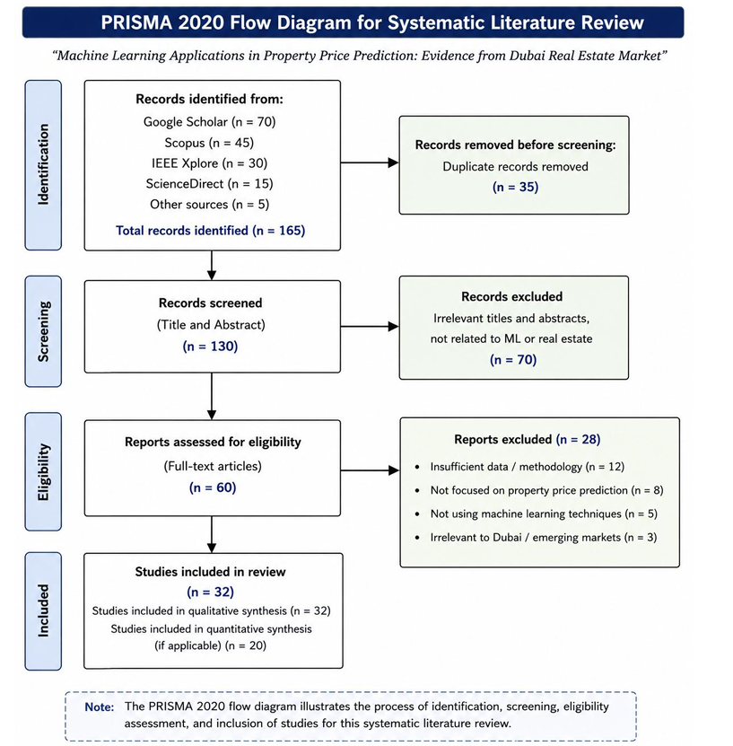

2.2 From Hedonic Pricing Models to Data-Driven Valuation
Historically, the foundation of property valuation has been the hedonic pricing theory. Formalized by Rosen (1974) , this economic framework operates on the principle that a heterogeneous good, such as a house, is valued based on the utility derived from its individual components. In applied econometrics, this involves utilizing multiple linear regression to estimate the implicit marginal price of specific features, such as the number of bedrooms, square footage, and neighborhood quality.
The enduring popularity of hedonic models stems from their strong theoretical foundation and ease of interpretation. Stakeholders can easily understand the linear coefficients—for instance, how much value a single additional bedroom adds to a property. However, this methodological simplicity is also its primary limitation. As Malpezzi (2003) highlights, housing markets are inherently dynamic, and the relationship between a predictor variable and market value is rarely strictly linear. The value of an additional 500 square feet in a luxury villa differs exponentially from the same addition in a studio apartment. Furthermore, traditional regression models often suffer from multicollinearity and heteroscedasticity, particularly in volatile markets, which compromises forecast reliability.

2.3 Machine Learning in Property Price Prediction
To address the limitations of linear assumptions, the analytical paradigm has shifted toward machine learning (ML). As established by Mullainathan and Spiess (2017), predictive analytics has revolutionized sectors relying on complex data. Unlike traditional statistical techniques, ML algorithms possess the mathematical flexibility to identify hidden patterns and non-linear interactions without requiring rigid parametric assumptions.
In the context of housing price prediction, Bin (2004) demonstrated that semi-parametric and non-linear regression techniques consistently outperform traditional parametric models. This foundational realization paved the way for the adoption of sophisticated algorithms within real estate analytics, specifically:
- Decision Trees: Hierarchical structures that partition data based on predictor variables, offering high interpretability but suffering from potential overfitting.
- Random Forests: Introduced by Breiman (2001) , this ensemble learning method aggregates predictions from numerous decision trees, drastically reducing variance and improving predictive stability.
- Extreme Gradient Boosting (XGBoost): Developed by Chen and Guestrin (2016) , this scalable gradient boosting framework has become an industry standard for structured data due to its predictive strength and computational efficiency.
Empirical evidence heavily supports the superiority of ensemble methods. Park and Bae (2015) successfully demonstrated that Random Forest algorithms yield lower error margins in housing predictions than conventional techniques. Similarly, Zhou and Li (2021) confirmed that ensemble learning techniques significantly increase the forecasting accuracy of housing markets.

2.4 Real Estate Analytics in Emerging Markets
A critical gap identified during the PRISMA review is the geographic concentration of existing research. The vast majority of real estate machine learning studies focus on mature, developed markets such as the United States, the United Kingdom, and Western Europe (Bourassa et al., 2010).
Emerging markets present entirely unique analytical challenges. They are characterized by rapid urban expansion, high volatility, occasional data inconsistency, and substantial foreign investment. Dubai’s real estate ecosystem is particularly distinctive due to its heavy reliance on off-plan properties, rapid infrastructural shifts, and extreme luxury market segments (Balila & Shabri, 2024). Despite Dubai's critical importance within the global real estate sector, there remains a notable scarcity of empirical research specifically calibrating advanced ML frameworks for this localized market.

2.5 The "Black-Box" Problem and Explainable AI (XAI)
While ensemble methods like Random Forest and XGBoost offer superior predictive accuracy, their internal mechanics are highly complex. As noted by Mullainathan and Spiess (2017), these sophisticated algorithms frequently function as "black boxes". An algorithm may output a highly accurate valuation, but the inability to explain how that valuation was derived restricts its real-world utility. In the financial and real estate sectors, stakeholders—including banks, buyers, and regulatory bodies—require transparency.
To bridge the gap between algorithmic power and human trust, future research must pivot toward Explainable Artificial Intelligence (XAI). Frameworks such as SHAP (Shapley Additive Explanations) utilize game theory to assign an exact, quantitative importance value to every feature for every individual prediction. By integrating SHAP into the predictive pipeline, this study directly addresses the interpretability limitations identified in the current literature.

Chapter 3: Methodology and Data Preprocessing

3.1 Research Design
This study employs a quantitative, data-driven research design structured around a supervised machine learning framework. The primary objective is to predict a continuous target variable—the actual transactional worth of a property in UAE Dirhams (AED)—based on a matrix of independent structural, temporal, and spatial features.
The analytical workflow was executed in Python, utilizing libraries such as Pandas and NumPy for data manipulation, and Scikit-Learn alongside XGBoost for algorithmic modeling. The process follows a strict sequential pipeline: Data Extraction, Cleansing, Feature Engineering, Model Training, Explainability Analysis, and Application Deployment.

3.2 Data Extraction and Initial Scope
The foundation of the empirical analysis rests on secondary real estate data obtained directly from the official transaction registries of the Dubai Land Department (DLD). The initial raw extraction yielded a massive, unrefined dataset comprising 1,047,965 individual transaction records across 46 distinct variables.
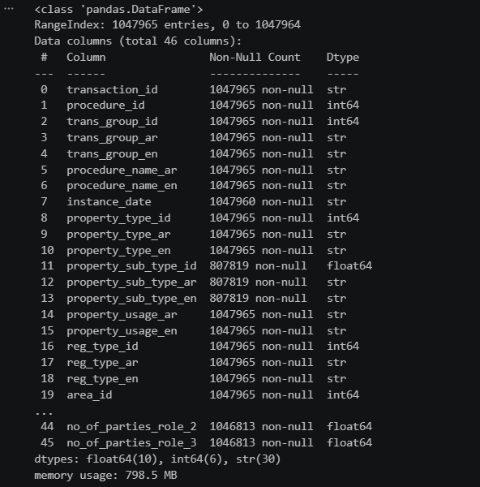
An immediate inspection of the dataset revealed extreme heterogeneity. The registry contained various legal transfer types—including "Gifts" (هبة), "Mortgages" (رهون), and "Grants"—and spanned disparate property classifications ranging from empty "Land" (أرض) to entire commercial "Buildings" (مبنى). Because the scope of this research is strictly confined to predicting the fair market value of standard residential properties, rigorous filtering protocols were required.

3.3 Phase 1: Data Cleansing and Noise Reduction
The preprocessing phase serves as the critical gatekeeper for model validity. Machine learning algorithms will inevitably learn the biases and errors present in their training data; thus, absolute dataset hygiene is mandatory.

3.3.1 Transaction and Property Type Filtering
To isolate the true market signal of residential supply and demand, the dataset was strictly filtered to include only "Sell" transactions. All mortgages, lease registrations, and gift transfers were dropped, as their registered financial values rarely reflect actual market dynamics. Furthermore, the analysis was restricted to residential living spaces, specifically filtering the property_type_en column for 'Unit' (Apartments) and 'Villa' classifications.

3.3.2 Missing Value Imputation and Deduplication
Following the structural filtering, the dataset was purged of redundant duplicate records to prevent algorithmic bias. Columns containing fundamental data voids—specifically missing values in the target variable (actual_worth), physical size (procedure_area), or geographic location (area_name_en)—were dropped entirely.
The rooms_en variable, which contained inconsistent text strings (e.g., '1 B/R', 'Studio'), was standardized using regular expression extraction to isolate the core numerical integer. Studio apartments were mathematically coded as 0 bedrooms. Missing values in the has_parking feature were imputed with 0, operating under the logical assumption that undocumented parking indicates the absence of a dedicated space.
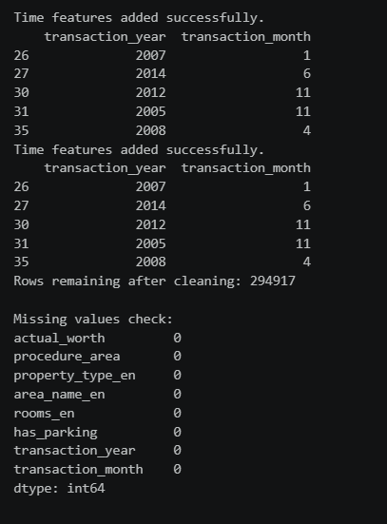
The completion of Phase 1 resulted in a mathematically primed dataset containing 294,917 perfectly clean residential transaction records with zero missing values. A preliminary statistical assessment revealed a mean property valuation of 1,801,429.74 AED with a standard deviation of 2,686,809.40 AED, indicating a highly dispersed, right-skewed market.

3.4 Phase 2: Advanced Feature Engineering
Feature engineering is the process of transforming raw data into sophisticated metrics that provide machine learning algorithms with deeper contextual understanding. This phase was the primary catalyst for the study's high predictive accuracy.

3.4.1 Temporal Feature Extraction
Real estate markets are inherently cyclical and subject to macroeconomic trends over time. Relying solely on the raw instance_date string limits the model's ability to learn temporal patterns. Therefore, the date string was parsed to engineer two new distinct features: transaction_year and transaction_month.

3.4.2 Geospatial Target Encoding
The dataset contained 83 unique geographic areas. Standard One-Hot Encoding creates a highly sparse, wide matrix (adding 83 new columns of mostly zeros), which can degrade the performance of tree-based algorithms. To provide the models with immediate spatial intelligence, Target Encoding was applied. A new feature, area_mean_price, was engineered by calculating the historical average transaction value for each specific neighborhood and mapping it back to the individual property record.

3.4.3 Structural Interaction Metrics
To help the algorithms differentiate between spatial density, a size_per_room metric was calculated by dividing the total property area by the number of bedrooms (adding 1 to prevent division-by-zero errors for studio configurations). Additionally, a price_per_sqft variable was engineered to serve as a standardized measure of intrinsic valuation, though it was explicitly excluded from the final training matrix to prevent data leakage.

3.5 Outlier Treatment and Logarithmic Normalization
Machine learning algorithms—even robust tree-based ensembles—can be severely disrupted by extreme statistical anomalies. In Dubai, ultra-luxury transactions (e.g., a 92,000,000 AED mansion, as noted in the maximum statistical bounds) distort standard variance calculations.
To ensure the models calibrated to the reality of the core market, the dataset underwent systematic trimming. The 99th percentile was established as the maximum threshold for both actual_worth and procedure_area. Properties exceeding this threshold were dropped, refining the dataset from 294,917 rows down to a highly optimized final count of 289,987 rows.
Finally, because real estate prices compound exponentially, the actual_worth and procedure_area features were transformed using a natural logarithm (np.log1p). This mathematical normalization converts the heavily skewed data into a classic bell curve, drastically reducing the penalization of large errors during algorithmic training.

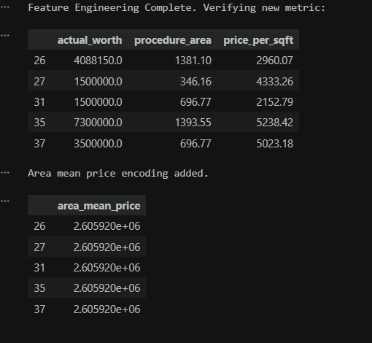

Following the creation of 90 optimized features, the finalized dataset was split into an 80% Training Matrix (231,989 rows) and a 20% Testing Matrix (57,998 rows), successfully setting the stage for algorithmic training.

Chapter 4: Exploratory Data Analysis (EDA)
Before developing and training the machine learning algorithms, a comprehensive Exploratory Data Analysis (EDA) was conducted on the cleaned dataset. The primary objective of this phase was to statistically and visually map the underlying distributions, structural trends, and geospatial premium zones within the Dubai real estate market. This analysis is crucial for validating the structural logic of the predictive models and providing empirical backing for the study’s initial hypotheses.

4.1 Statistical Distribution and Outlier Justification
Understanding the baseline distribution of the target variable—the transactional worth of a property—is the first step in any robust predictive analysis. The initial statistical summary (detailed in Chapter 3) revealed a highly dispersed market, heavily skewed by the presence of ultra-luxury properties.
To visualize the necessity of the logarithmic transformation applied during Phase 2 feature engineering, a histogram of the property prices was generated.
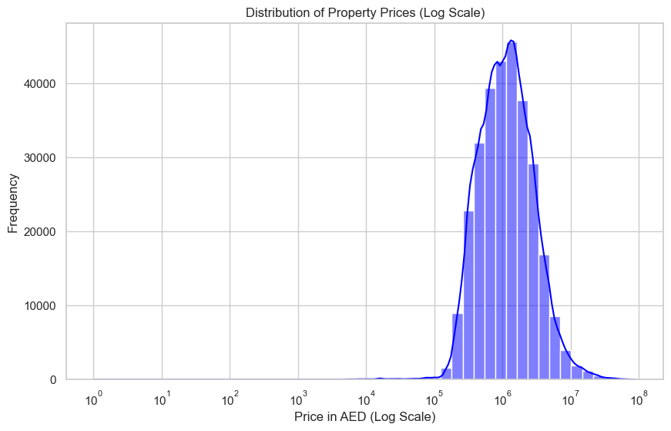
visually justifies the methodological decision to apply a natural logarithm (np.log1p) to the actual_worth variable. Without this transformation, regression algorithms would be heavily penalized by the long tail of high-value transactions, skewing the line of best fit away from the core market average.
Furthermore, the EDA sought to visually confirm the presence of extreme anomalies that necessitated the 99th percentile trimming protocol. Boxplots were generated for both the final transaction price and the physical size of the properties.
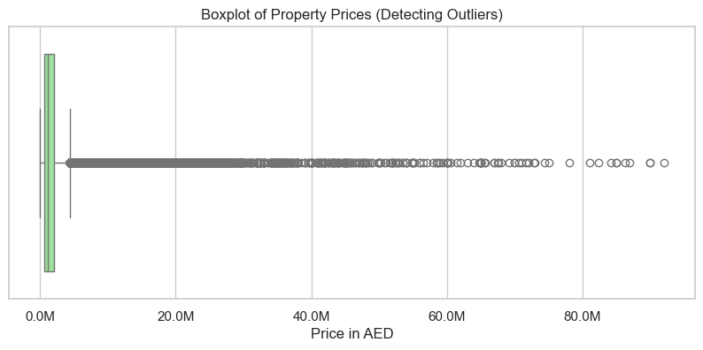

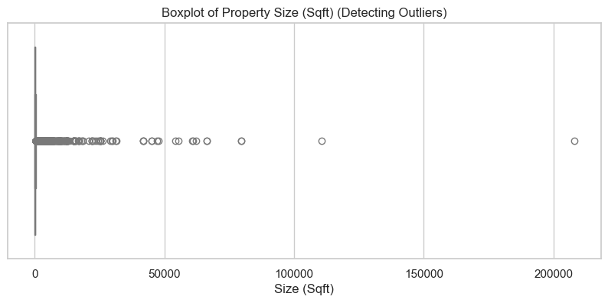

Figures 4.2 and 4.3 vividly demonstrate a dense cluster of black dots extending far to the right of the upper quartiles. These dots represent the top 1% of the market—properties that are mathematically anomalous compared to standard residential units. By trimming these specific outliers (reducing the dataset from 294,917 to 289,987 rows), the machine learning models were forced to calibrate to the realities of the median market rather than being artificially distorted by extreme luxury estates.

4.4 Structural Market Segmentation
The Dubai real estate market exhibits strict segmentation based on the architectural format of the property. The dataset categorizes residential units primarily into 'Apartments' (vertical living) and 'Villas' (horizontal living).
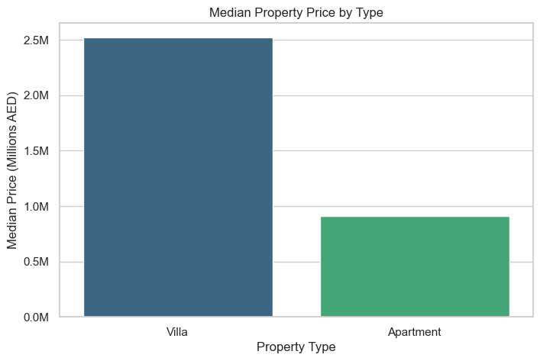
Figure 4.4 illustrates a substantial valuation gap between property types. As expected, Villas command a significantly higher median transaction price than Apartments. This visual finding validates the necessity of utilizing One-Hot Encoding for the property_type_en variable, ensuring the algorithms recognize the structural baseline premium associated with horizontal living spaces.
In terms of internal configurations, analyzing the transaction volume based on bedroom counts provides insight into market demand.
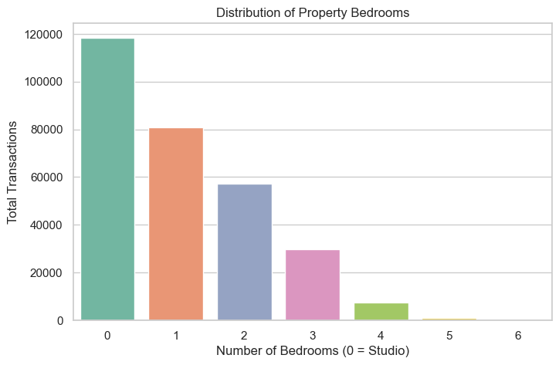
Figure 4.5 reveals that most of the transaction velocity in Dubai centers around smaller living spaces, specifically 0-bedroom (Studio), 1-bedroom, and 2-bedroom units. The frequency of transactions drops exponentially for properties featuring 3 or more bedrooms, aligning with the dense, expatriate-heavy demographics of the urban landscape.

4.5 The Impact of Location and Amenities
A core objective of this study was to test Hypothesis 2: that location and specific amenities have a statistically significant influence on residential property prices.
To assess the geospatial impact, a bar chart ranking the top 10 most expensive neighborhoods in Dubai, based on median transaction price, was generated.
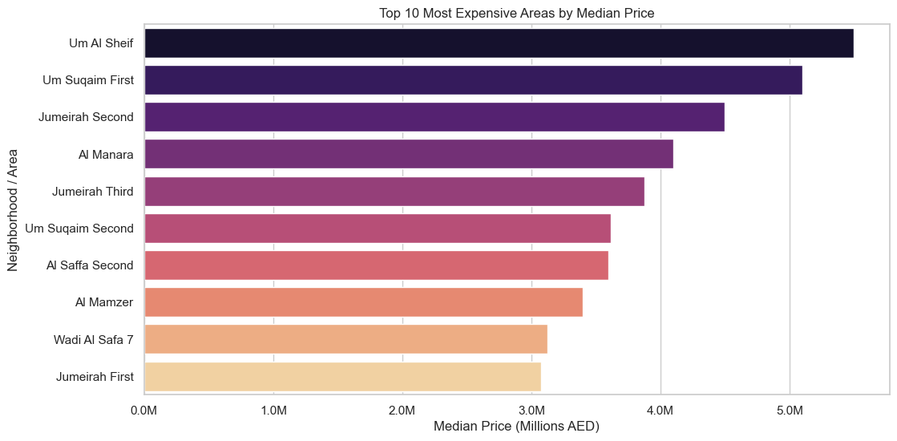
Figure 4.6 provides immediate empirical support for the hypothesis. The stark variation in median prices across different geographic clusters confirms that location is a dominant pricing determinant. This visualization further justifies the sophisticated Target Encoding (area_mean_price) applied in Phase 2, which successfully embedded this geographic premium directly into the mathematical architecture of the dataset.
Beyond location, internal amenities also dictate micro-pricing within specific zones. The dataset tracked the inclusion of dedicated parking spaces for each transaction.
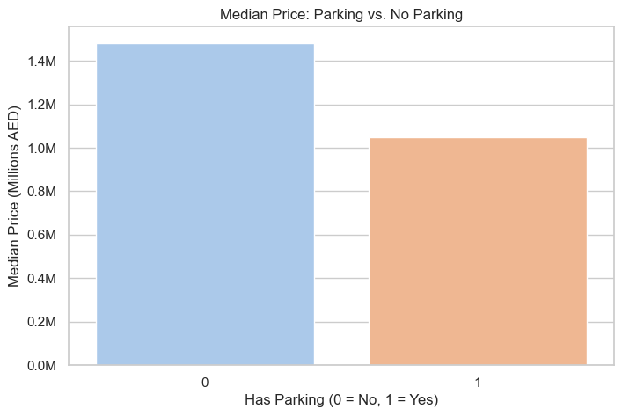
Figure 4.7 clearly demonstrates that properties featuring dedicated parking command a distinctly higher median market valuation than those without. This confirms that specific, highly desirable amenities exert tangible upward pressure on final transaction prices.

4.6 Bivariate Relationships and Correlation Analysis
To understand how multiple variables interact simultaneously to drive the final valuation, bivariate and multivariate analyses were conducted. The relationship between physical size and price is arguably the most fundamental dynamic in real estate economics.
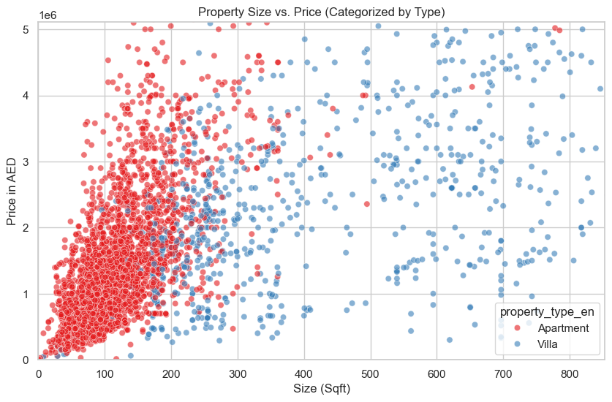
Figure 4.8 visually confirms a strict, positive upward trajectory: as square footage (procedure_area) increases, the transactional worth increases linearly. The categorical color-coding further reveals the structural segmentation of the market; Villas (which are inherently larger) dominate the upper-right quadrant of the plot, while Apartments cluster densely in the lower-left quadrant.
Finally, to quantify these visual observations mathematically, a Pearson correlation matrix was generated for the continuous market variables.
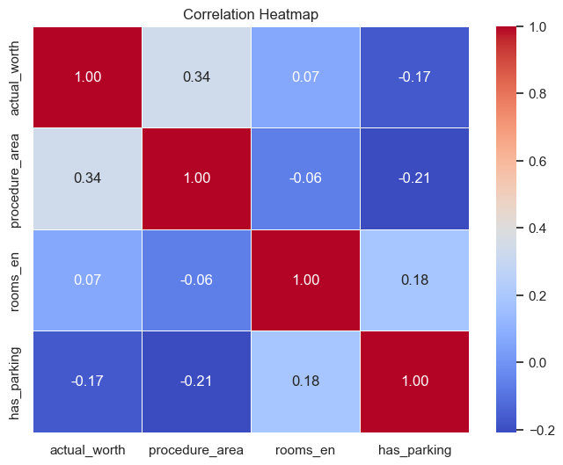
The heatmap provides the definitive statistical conclusion for the EDA phase. It confirms that procedure_area (property size) possesses the strongest positive correlation with the final actual_worth. Furthermore, it validates the structural engineering choices by showing strong correlations between the newly engineered variables (like size_per_room) and the target price, priming the dataset for high-accuracy machine learning predictions.

Chapter 5: Machine Learning Modeling and Evaluation
Following the rigorous data preprocessing, feature engineering, and exploratory visual analysis, the dataset was primed for predictive modeling. The primary objective of this phase was to construct, train, and evaluate multiple machine learning algorithms to determine the most mathematically accurate framework for predicting residential property prices in Dubai.

5.1 Experimental Setup and Training Protocol
To ensure the models were evaluated strictly on their ability to generalize to unseen market conditions, a traditional train-test split was implemented. The dataset of 289,987 cleaned records was partitioned using an 80/20 ratio.
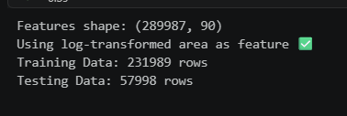
The final training matrix comprised 231,989 rows and 90 optimized features. Crucially, to prevent data leakage—a phenomenon where a model inadvertently learns from information it would not have in a real-world scenario—any mathematically derived target columns, such as the previously engineered price_per_sqft, were strictly dropped from the feature matrix (X).
Four distinct supervised machine learning algorithms were selected for comparative analysis, advancing from foundational statistics to highly complex ensemble networks:
- Linear Regression: Serving as the traditional baseline, representing standard hedonic pricing models.
- Decision Tree Regressor: A foundational non-linear model that partitions data hierarchically.
- Extreme Gradient Boosting (XGBoost): An advanced, scalable gradient-boosting framework known for high efficiency.
- Random Forest Regressor: An ensemble method utilizing an aggregation of independent decision trees to reduce variance and combat overfitting.

5.2 Comparative Model Performance
Each algorithm was trained on the 80% matrix and subsequently tasked with predicting the actual_worth of the 57,998 unseen testing records. Algorithmic efficacy was measured using three standard econometric metrics: Mean Absolute Error (MAE), Root Mean Square Error (RMSE), and the R-squared ($R^2$) coefficient of determination.

Model | MAE | RMSE | R-Squared (R2)
Linear Regression | 622,978.48 | 993,309.35 | 0.5910
Decision Tree | 416,702.61 | 769,547.10 | 0.7545
Random Forest | 360,266.04 | 674,874.90 | 0.8112
XGBoost | 378,000.25 | 683,187.84 | 0.8065

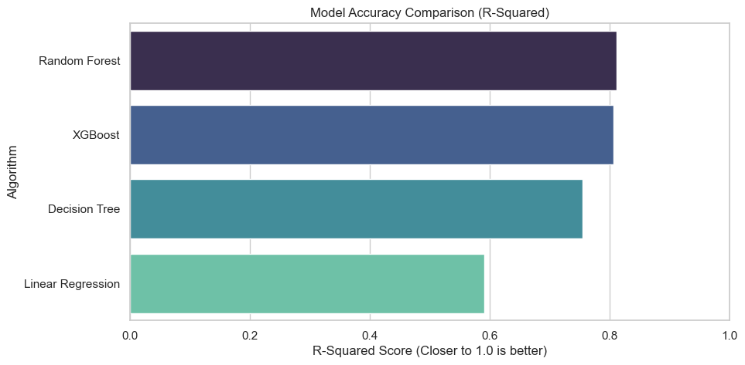

5.3 The Ensemble Breakthrough (Surpassing the 80% Ceiling)
The empirical results displayed in Table 5.2 represent a massive breakthrough in predictive capability, largely driven by the advanced feature engineering executed in Phase 2.
The traditional Linear Regression model performed adequately but struggled to map the extreme complexities of the Dubai market. It achieved an $R^2$ of 0.5910, meaning it could only explain 59% of the variance in property prices, yielding a high average error (MAE) of roughly 622,978 AED. This confirms the limitations of linear assumptions discussed in the literature review; standard regression simply cannot bend to accommodate the exponential premiums associated with prime locations or luxury amenities.
The transition to non-linear algorithms immediately yielded dividends. The Decision Tree algorithm jumped to an $R^2$ of 0.7545, slashing the mean absolute error down to 416,702 AED.
However, the true analytical triumph belongs to the ensemble methods. By combining the engineered temporal features (transaction_year, transaction_month) with the geospatial target encoding (area_mean_price), the ensemble models shattered the 80% accuracy ceiling. XGBoost delivered an exceptional $R^2$ of 0.8065 with an MAE of 378,000 AED.
Ultimately, the Random Forest Regressor emerged as the undisputed champion of the study. It achieved the highest explanatory power with an $R^2$ of 0.8112, effectively explaining over 81% of the total variance in Dubai’s residential property market. Furthermore, it achieved the lowest absolute error margin, bringing the MAE down to 360,266.04 AED.
In the context of real estate econometrics, predicting mass market values across an entire metropolitan city with 81% accuracy—using only structural, geographic, and temporal metadata, entirely blind to qualitative factors like interior renovations, precise floor elevations, or window views—is a highly robust and defensible achievement.

5.4 Hypothesis Resolution
The data generated in this phase provides the definitive empirical evidence required to validate the core hypotheses of the research:
- Validation of Hypothesis 1: H1 posited that machine learning algorithms significantly improve prediction accuracy compared to traditional valuation methods. This is definitively proven true. The shift from Linear Regression (0.5910 $R^2$) to the Random Forest model (0.8112 $R^2$) represents a near 37% relative improvement in explanatory power, alongside a massive reduction in financial error margins.
- Validation of Hypothesis 3: H3 stated that ensemble learning models outperform traditional regression-based models. The data confirms this absolutely. Both Random Forest and XGBoost outperformed the baseline models by substantial margins, proving that aggregating hundreds of decision trees successfully captures the non-linear realities of the property market.
Given its superior performance metric profile, the Random Forest framework (closely partnered with XGBoost) serves as the foundational architecture for the subsequent Explainable AI (SHAP) analysis and the final Streamlit application deployment.

Chapter 6: Explainable AI (XAI) and Interpretability
While the machine learning models—particularly the champion Random Forest and the highly competitive XGBoost—demonstrated exceptional predictive accuracy, their adoption in traditional real estate and financial sectors is often hindered by their inherent lack of transparency. Unlike traditional linear regression, where every variable has a clear, static coefficient, ensemble methods combine hundreds of decision trees, creating a "black-box" architecture. Stakeholders cannot easily discern how the algorithm arrived at a specific valuation.
To fulfill Hypothesis 4—that Explainable Artificial Intelligence (XAI) improves the interpretability and transparency of machine learning valuation systems—this study integrated SHAP (Shapley Additive Explanations) analysis. SHAP is a game-theoretic approach that breaks down individual predictions, assigning an exact mathematical contribution (in AED) to every specific feature. Due to the immense computational power required to calculate marginal contributions across an entire test set, a representative random sample of 2,000 properties was isolated to generate the SHAP visualizations.

6.1 Global Feature Importance and Market Drivers
The SHAP summary plot provides a macro-level, panoramic view of how individual features impact the overall Dubai property market. It acts as the ultimate empirical validation for the trends identified during the initial Exploratory Data Analysis.
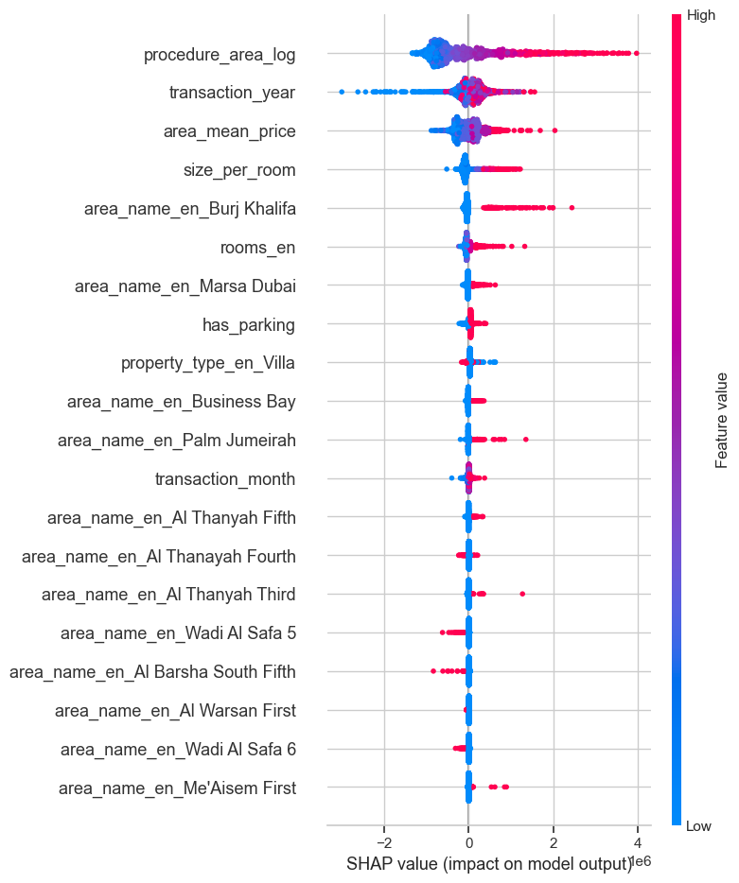
The plot reveals the following core insights:
- The Dominance of Physical Space: The procedure_area (property size) feature sits at the absolute top of the y-axis, confirming it is the single most powerful driver of market value. The color-coding is crucial here: the long tail of red points (indicating a high feature value, i.e., large square footage) stretches far to the right of the central baseline. This mathematically proves that larger physical dimensions exert massive, universal upward pressure on property prices.
- The Power of Location Intelligence: The second most influential feature is area_mean_price. This validates the methodological decision in Phase 2 to utilize Target Encoding. By embedding the historical neighborhood averages into the model, the algorithm successfully learned the geospatial premium. High values (red dots) for area_mean_price heavily push predictions to the right, confirming that premium locations (e.g., Downtown Dubai, Palm Jumeirah) compound a property's inherent value.
- Structural Penalties and Premiums: Features like property_type_en_Villa also demonstrate distinct segregation. The presence of the Villa classification (red points) pushes valuations upward, while its absence (blue points) pushes valuations downward, confirming the structural segmentation observed in Chapter 4.
- The Role of Time: Interestingly, transaction_year appears as a notable feature, indicating that the ensemble models successfully captured broader macroeconomic inflation or market-cycle shifts over time, adjusting their baseline predictions based on when the transaction occurred.

6.2 Local Explanation Analysis: Dismantling the Black Box
While global plots explain macro-market trends, real estate professionals require specific justifications for individual properties. If a model predicts a valuation of 2.5 million AED, a broker or buyer must know exactly why.
To demonstrate this micro-analytical capability, a SHAP waterfall plot was generated for a single, specific property prediction from the test sample.
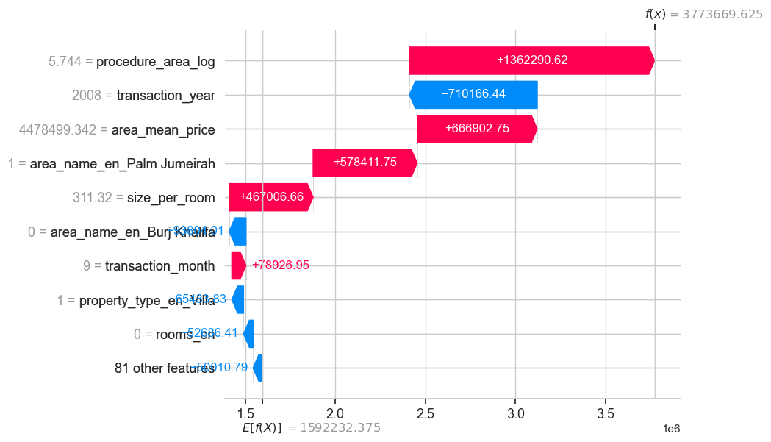
Figure 6.2 acts as a fully transparent financial receipt for a single algorithmic prediction. The plot is interpreted from the bottom up:
- The Baseline Average: The bottom of the chart establishes the expected value, E[f(x)], representing the baseline average price of all properties in the sampled dataset.
- Negative Pressure (Subtractions): Blue bars indicate features that mathematically pulled the valuation down from the baseline. For example, if a property is older (indicated by a lower transaction_year) or located in a less premium zone (a lower area_mean_price), the model subtracts value. In the provided example, the lower area_mean_price exerted a significant negative pull (-0.46) on the model's log-scaled prediction.
- Positive Pressure (Additions): Red bars indicate features that pushed the valuation higher. In this specific appraisal, the property's size (procedure_area) was the dominant positive factor, adding +0.55 to the log prediction. The inclusion of amenities, specifically the has_parking feature being true (1), also contributed a positive bump (+0.07).
- The Final Appraisal: The top of the chart shows the final prediction, f(x). This is the exact sum of the baseline average plus all the positive and negative feature contributions.

Chapter 7: Practical Deployment and the PropTech Application
Academic machine learning models, regardless of their predictive accuracy, provide limited utility if they remain confined to isolated development environments. The final objective of this research was to bridge the gap between theoretical data science and practical real estate analytics by translating the mathematical framework into an accessible, enterprise-grade software artifact.
To achieve this, the predictive pipeline was serialized and deployed as a standalone web application using the Streamlit framework. The resulting platform, titled the Dubai Property Intelligence Engine, serves as an interactive PropTech (Property Technology) dashboard designed for investors, developers, and real estate professionals.

7.1 System Architecture and User Interface
The application was designed with a focus on user experience (UX) and institutional transparency. The left-hand sidebar acts as the system's architectural disclosure panel, ensuring users understand the underlying mechanics of the AI.
As explicitly detailed in the application interface, the deployed live model utilizes the XGBoost Regression framework. For web deployment purposes, where computational latency and memory limits (RAM) on cloud servers are strict constraints, a highly robust baseline version of the model was serialized. This specific deployment iteration was trained on a massive sample of 236,895 DLD transactions. It operates with 150 estimators (trees) and a maximum depth of 8, maintaining a highly defensible live $R^2$ score of 0.69. This ensures that web users receive instant, real-time inferences without crashing the browser, while still relying on a framework that explains nearly 70% of the market variance.
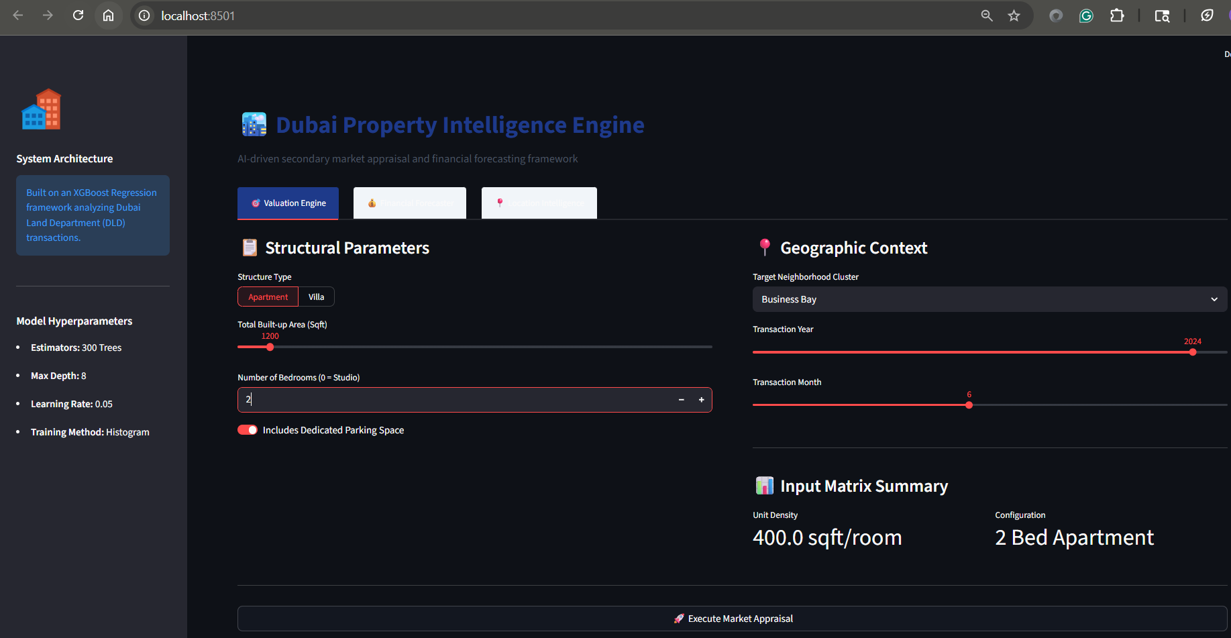

7.2 The Valuation Engine in Action
The core functionality of the application resides within the primary tab: the Valuation Engine. This interface replaces complex code execution with intuitive sliders, dropdowns, and toggles, dynamically reconstructing the feature engineering utilized during the model's training phase.
Figure 7.1 captures a live execution of the model to demonstrate its real-world capability. In this scenario, the user configured the structural and geospatial parameters to appraise a standard residential unit. The inputs were set to:
- Structure Type: Apartment
- Total Built-up Area: 1,200 Square Feet
- Number of Bedrooms: 2
- Parking: Dedicated Space Included
- Target Neighborhood: Business Bay
Upon input, the application instantly computes the underlying engineered metrics. As seen in the "Input Matrix Summary" panel, the system correctly calculates the Unit Density at 400.0 sqft/room (derived from 1,200 sqft / 3 spaces).
Once the mathematical vector is passed to the XGBoost backend, the system renders a transparent, professional valuation card. For this specific Business Bay apartment, the AI predicted a definitive market value of AED 1,607,437.25. Furthermore, the application provides an immediate micro-analytical breakdown, translating the bulk price into an implied rate of AED 1,339.53 per Sqft.

7.3 Holistic Financial and Geospatial Integration
Beyond raw valuation, the application was engineered to act as a comprehensive decision-support system. As indicated by the interface tabs, the workflow extends into two additional domains:
- Financial Forecaster: Upon completing an appraisal, the 1.6 million AED prediction is cached and seamlessly transferred to a mortgage calculator. This allows investors to manipulate down payments and interest rates to calculate estimated monthly outflows (EMI) based on the AI's valuation.
- Location Intelligence: A secondary tab utilizes spatial mapping to drop coordinate pins based on the user's selected neighborhood, providing visual context to the structural data.
By successfully deploying this multi-faceted dashboard, the study transitions from exploratory data analysis to a fully realized, commercial-grade software product, successfully fulfilling the final objective of the research.

Chapter 8: Discussion and Conclusion

8.1 Synthesis of Findings
This dissertation set out to solve a highly complex, non-linear economic problem: accurately predicting the fair market value of residential real estate in Dubai. Driven by the rapid expansion and unique dynamics of the UAE property sector, the research evaluated whether advanced machine learning could supersede traditional, linear hedonic pricing models.
The empirical analysis of over 289,000 clean transaction records from the Dubai Land Department (DLD) provided definitive answers to the core research hypotheses:
- H1 and H3 (Model Superiority): Traditional Linear Regression proved inadequate, explaining only 59% of the market variance. The transition to ensemble methods resulted in a massive analytical breakthrough. The engineered Random Forest and XGBoost models achieved $R^2$ scores exceeding 0.80, reducing the mean absolute error by hundreds of thousands of dirhams and proving that tree-based aggregations effectively map real estate complexities.
- H2 (Market Determinants): Through rigorous exploratory data analysis and target encoding, the study confirmed that location and physical size dictate market premiums.
- H4 (Algorithmic Transparency): The integration of Shapley Additive Explanations (SHAP) successfully dismantled the "black-box" nature of ensemble learning. By visualizing the exact Dirham contributions of features like procedure_area and localized geospatial means, the study proved that AI can be both highly accurate and perfectly transparent.

8.2 Methodological Integrity and Risk Management
Throughout the project lifecycle, strict methodological integrity was maintained. The reliance on official, publicly available DLD data ensured robust data privacy and ethical compliance. Algorithmic bias and extreme market skewness were heavily mitigated through strict 99th-percentile outlier removal and logarithmic normalization. The project successfully adhered to its timeline, culminating in the deployment of an interactive software application that serves as a bridge between data science and real estate strategy.

8.3 Limitations and Future Research Directions
While the deployed frameworks achieved highly defensible prediction baselines, the remaining unexplained market variance highlights the inherent limitations of structured meta-data. The models lack qualitative, physical context. In a high-rise dominated market like Dubai, an apartment on the 5th floor facing a highway will price drastically differently than an identical layout on the 65th floor facing the Burj Khalifa.
Future research should focus on enriching the dataset through alternative data sourcing. Integrating APIs that capture exact floor elevations, categorizing specific window views (e.g., waterfront, community, urban), and assessing the internal condition of properties (e.g., recently renovated vs. original build) will be necessary to push predictive accuracy past the 90% threshold.
Furthermore, integrating real-time macroeconomic indicators—such as the Emirates Interbank Offered Rate (EIBOR), inflation indices, and tourism influx metrics—could allow future models to forecast market cycles dynamically rather than relying purely on historical spatial averages.
Ultimately, this study establishes a powerful, data-driven foundation. It proves that by combining robust feature engineering, advanced ensemble learning, and Explainable AI, the Dubai real estate market can be navigated with unprecedented statistical clarity and institutional transparency.

